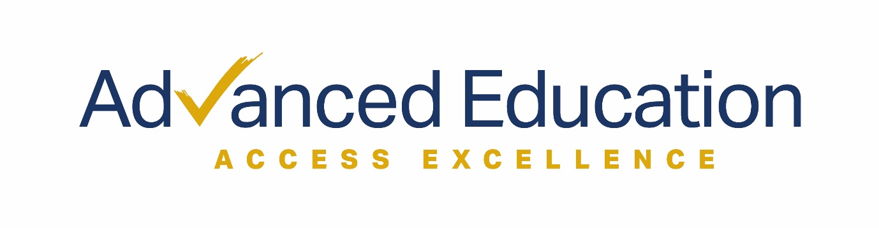

2021 Term Dates

Year 11 | Start Date | End Date | No. of Classes
Term 1 | 30/01/21 | 10/04/21 | 11
Term 2 | 01/05/21 | 03/07/21 | 10
Term 3 | 24/07/21 | 25/09/21 | 10
Term 4 | 16/10/21 | 11/12/21 | 9
Total |  |  | 40
Year 12 | Start Date | End Date | No. of Classes
Term 1 | 30/01/21 | 10/04/21 | 11
Term 2 | 01/05/21 | 03/07/21 | 10
Term 3 | 24/07/21 | 30/10/21 | 15
SACE Exams | November
Total |  |  | 36

2021 Fees

Saturday Classes: $35 per class
Private session online: $65
Private session in-person: $80

